**Lab4 Report**

Jian Wang

09/17/2013

1. a. Make and copy test_file.txt to hadoop HDFS

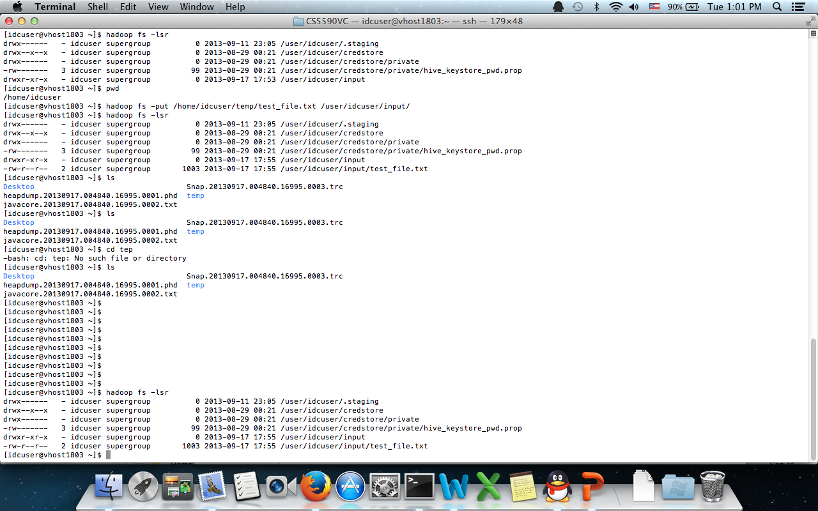

b. Run MapReduce Programs and generate output file

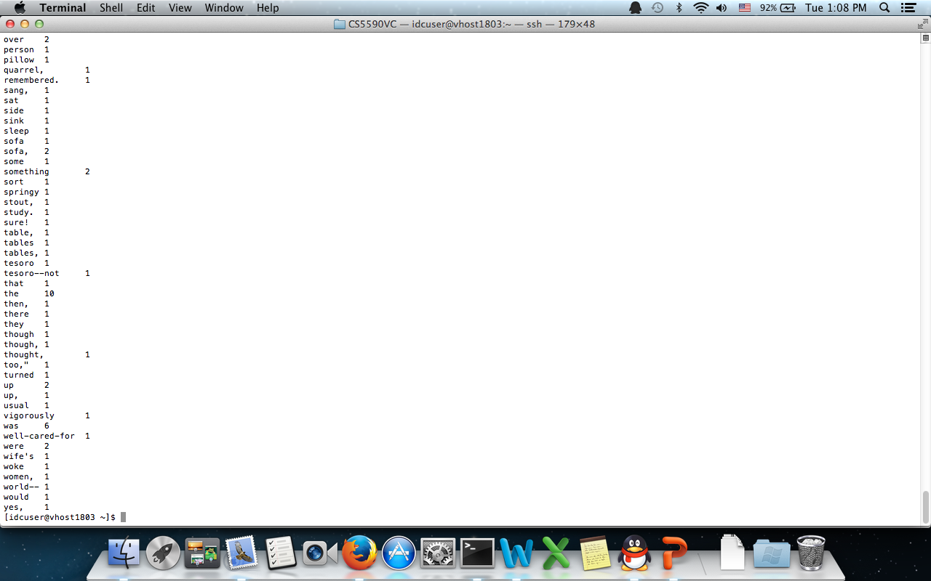

1. The input directory is /user/idcuser/input, and output directory /user/idcuser/output2

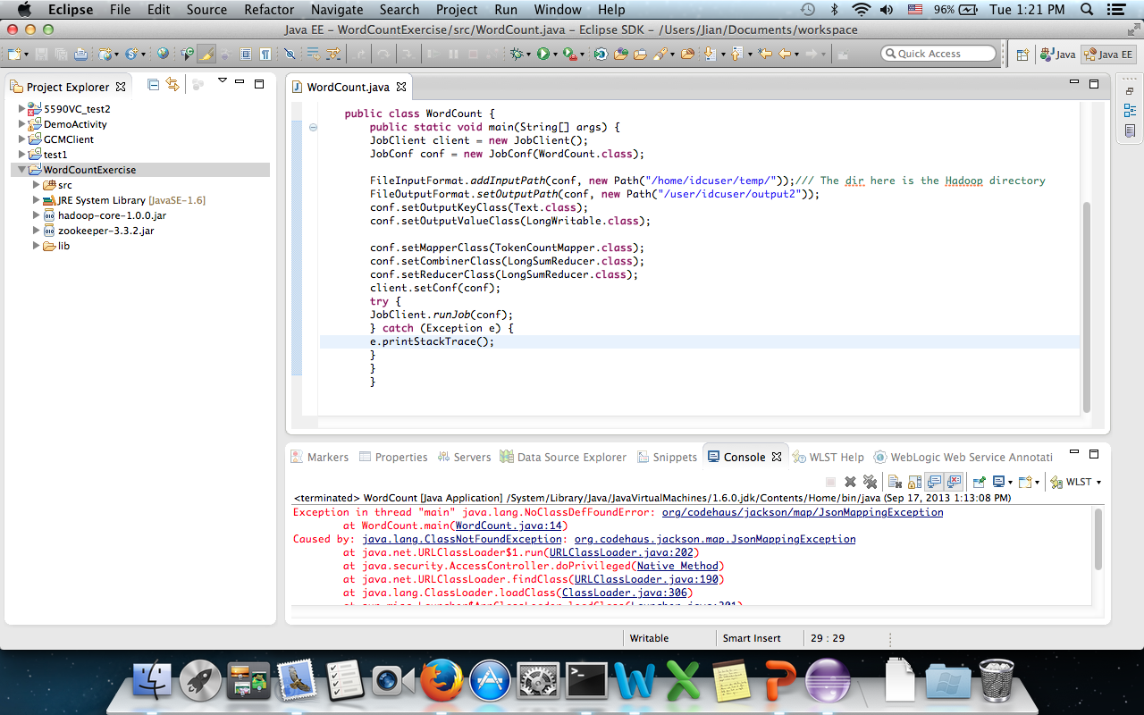

The output file looks like:

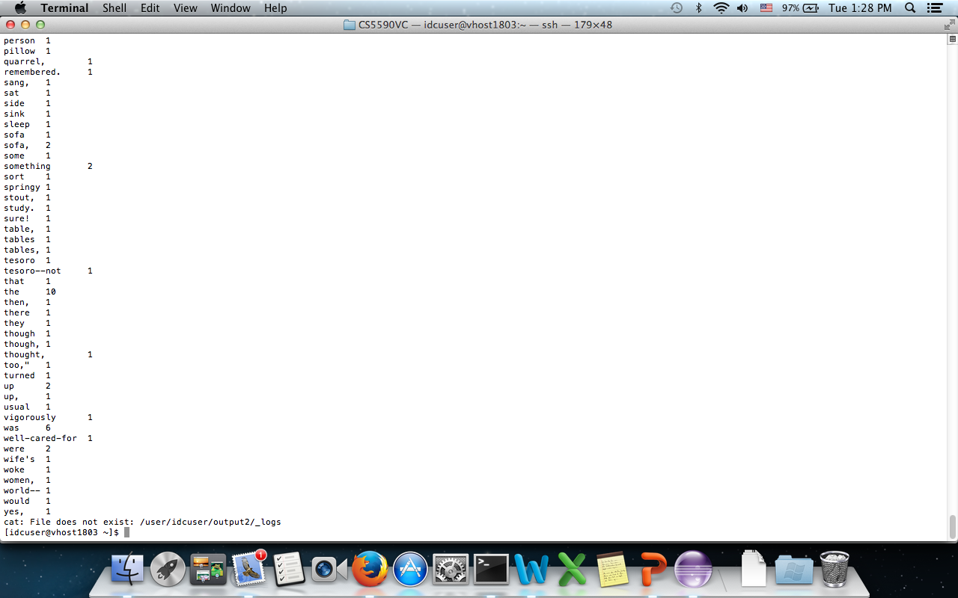

1. In order to create new map reduce algorithm, I added several lines of codes to wordcount.java file. When running it on hadoop instance, it complained error saying incompatible format. The file has been uploaded to github folder (same one as this report)

4. I tried more than 10 times on different hadoop instances and HDFRestWS file, but still can’t connect to hadoop instances after deploy web services.

